Day 37 – Proper Epidemiological Comparison Emerging from Statistics

The good news at a national level is epidemiological news. Dr Zouberr Joomye, who is for some reason (maybe that he is a transfiz and then not elected in the last elections), the Government spokesperson at the Coronavirus press briefings announced the key figures we in LALIT were waiting for i.e. the number of deaths, month by month, for 2019 and 2020. This was in reply to a question from the Press.

The figures suggest no sign of out-of-control, invisible spread of Covid in the population.

This is important news in itself, and also because of Navin Ramgoolam’s irresponsible statements. And also because some of the media, as well as droves on the internet, have persisted in spreading a kind of low-key fear that there is a huge “iceberg” of cases of Covid-19 under the tip of published Government statistics and that there are even alleged hidden deaths. These insinuations spread like wild-fire amongst people who do not use the free, universal hospital services and their ignorance of this excellent service probably makes them more liable to believe far-fetched things. To make these insinuations and rumours more pernicious, there are, in fact, real dangers of not knowing how many cases there are because of the high number of people without Covid-19 symptoms who nevertheless spread the disease. The inability to test whole cross-sections of people – this is true in almost all countries except South Korea and Germany – has added to the power of the insinuations. And, then again, this is not a Government that inspires generalized confidence. We, in LALIT, for example, charge the Government with bowing down, like minions, to the sugar cane bosses and other big land owners.

But, now the figures are out. Study these figures for a minute:

Deaths: Jan-Apr 2019 and 2020
 | Total Deaths |  | Deaths due to Respiratory Problems
Month | 2019 | 2020 | 2019 | 2020
Jan | 983 | 915 | 137 | 96
Feb | 826 | 826 | 112 | 110
Mar | 930 | 906 | 145 | 129
April | 845 | 446* | 104 | 56*
Note: *1-16 Apr 2020
Source: MOH+ Civil Status
NCC Press Briefing 25 April 2020

The slightly lesser figures for 2020 are not necessarily strange: The lockdown will have decreased the spread of flu and cold viruses, as well – that can have a toll on people with underlying health problems – and there will have been fewer road accidents and work injuries.

Take the above table together with three bar charts (below) for coronavirus figures day-by-day to date for total positive cases (note the curve flattened completely, so far), the new cases by day (a bit sporadic but tending downwards, and we can expect new outbreaks here and there for a long time), and the total active cases (in Mauritius this differs from other countries because the State admits all positive cases into hospital or quasi hospital institutions), which has decreased to manageable proportions.

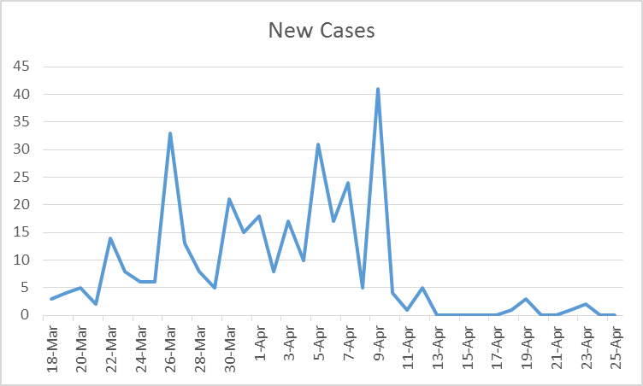

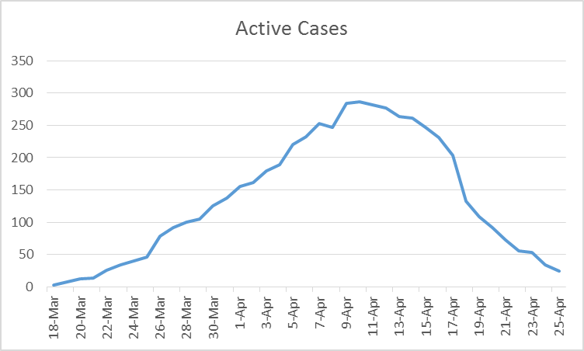

And this is what we can, for the moment, conclude:

1. The lockdown (including the one week of total curfew) was just in time, and has thus worked to flatten and bend down the various curves, signifying a degree of actual containment of the spread of the virus. This is a credit to people of Mauritius understanding the importance of this, despite the Government not explaining very clearly, and despite the Government being one that is tolerated but not particularly popular (remember although they won 2/3 of seats in the National Assembly in the November elections, they did not muster the well-nigh compulsory celebratory public meeting!)
2. The people of Mauritius have managed the social distancing rules, have worn masks when they have gone out, have washed their hands a lot and avoided touching their faces. The universal hand-shaking every day has totally disappeared. As has cheek-kissing. Many people wear gloves in public. Coughs and sneezes are aimed, even when people are wearing masks, I notice, into the bend of their elbows. It has become normal to have sanitizer pumped into your hands or gloves twice before you get into a supermarket and to have your temperature taken at the lintel of the supermarket – of all places.
3. The quarantine of people, in particular, the Government putting them up in empty hotels, if they have been in any way exposed to the virus (coming from abroad, working in hospitals) was important, too, in severely containing the spread.
4. The unusual measure of the hospitalization of all Covid 19 positive people, even those who are asymptomatic, has tightened up containment even more.
5. Perhaps key to the relative success (so far) has been the fantastic “trace-and-test” teams in Mauritius – who have then permitted the complete isolation in hospitals of all who test positive, i.e. even people who are without any symptoms.
6. Rodrigues and Agalega have been completely spared the virus by the timely lockdown.

There is other good news on the national front. In response to an outcry from unions, us in LALIT, consumer groups and others, at the exploitative pricing of essential goods, there is now a much-expanded list of price-controlled goods. Here is a link where you can access it:

https://www.lalitmauritius.org/modules/documents/files/LalitMauritius-f9b902fc3289af4dd08de5d1de54f68f.pdf

On the Ragoo Lane front, we have a beautiful air potato (pom-deler) on the front fencing, ready for harvest. It is truly the most remarkable staple food crop of all. It is completely autogestionary. Like so many vegetables, it seems to come from South America. The only problem with it is that it can be invasive, so plant it in a barrel to begin with, until you know its ways.

Lindsey Collen
for LALIT, a personal view.

